Google HashCode Competition

TIME TO MAKE USE OF THAT CIS 2166 DOBOR KNOWLEDGE!

Notes:

* Task: Given the description of a city plan and planned paths for all cars in that city, optimize the schedule of traffic lights to minimize the total amount of times spent in traffic, and help as many cars as possible reach their destination before a given deadline
* SEEMS LIKE A WEIGHTED DIGRAPH PROBLEM
* Traffic lights-red or green
* One way street
* Takes a fixed amount of time ‘L’ to get from beginning of street to end. ‘T + L’ seconds for a car to reach the end of the street if it enters the street at time ‘T’
* EXAMPLE:
* 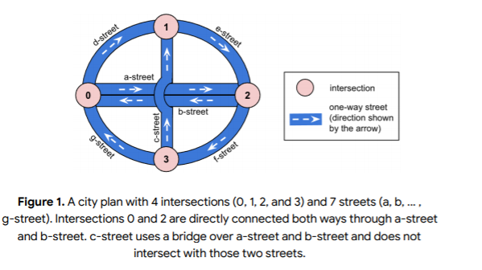
* Each intersection: has a unique integer ID (0,1,2,3) and has at least one street coming in and coming out
* Traffic light at the end of every street; at most one light will be green at an intersection at a time
* Queuing up: when the light is green, one car can cross the intersection every second. If a green light lasts T seconds, the first T cars can go through the intersection
  + IDEA: The intersections with only one incoming street have two outgoing streets, so those people incoming to that intersection should wait longer than people at an intersection with two incoming streets, for efficiency
  + IDEA: We should consider where the most traffic would build up and where it is better for traffic to build up, as well as where it is better to have quick-changing lights
  + IDEA: maybe we just close/red-light a street, b street, and c street so that all intersections are still reachable and the lights will always be green on those lights and they can reach to any intersection they would need to.
    - Not sure about this one, because the extra outgoing streets in the middle (a-c) might be able to save time
    - Actually, we cannot do this based on the logic of cars described below!!
* Schedule: each intersection has a set schedule. It is a list of pairs (incoming street, duration). Each street can appear at most once in schedule
  + We can ignore streets if that would help
* By default, all lights on all intersections are red (cars stuck there will have to wait there until the end of the simulation)
* Each Car: set path; can go through a single intersection at most once
  + All cars start at the end of the first street in their path, waiting for green
  + No delay when crossing
  + ONE CAR/SECOND
  + When a car enters the last street of its path and drives the whole street, it is removed from the street